Contents

New Variables — Creation, Updating and Scoping 3

let & const in real world 3

var Scoping Refresher 4

let versus const 4

let and const in the Real World 4

Temporal Dead Zone 6

Is var Dead? What should I use? 6

Function Improvements: Arrows and Default Arguments 6

Arrow Functions Introduction 7

More Arrow Function Examples 8

Arrow Functions and ‘this’ 8

Default Function Arguments 9

when not use arrow functions 9

Arrow Function Exercises 10

arrow functions and 'this' 10

**Template Strings** 11

Strings Introduction 11

Tagged Template Literals 11

Tagged Templates Exercise 11

Sanitizing User Data with Tagged Templates 11

New String Methods 11

new Strings methods example 11

Abreviations 15

Sanitizing data 17

Using the unminified development version 17

Using the minified and tested production version (source-map available) 18

What is ECMA and ES6?

JavaScript was originally named JavaScript in hopes of capitalizing on the success of Java.

Netscape then submitted JavaScript to ECMA International for Standardization. (ECMA is an organization that standardizes information)

This results in a new language standard, known as ECMAScript.

Put simply, ECMAScript is a standard. While JavaScript is the most popular implementation of that standard. JavaScript implements ECMAScript and builds on top of it.

If you try to use modern syntax to recreate a familiar old technique, or stick it in without understanding how it actually behaves, you run the risk of:

* having to debug code that worked perfectly before
* introducing subtle mistakes that may catch you at runtime only and potentially not even in QA
* creating code that fails silently when you least expect it.

In fact, several of the changes that appear to be drop-in replacements for existing techniques actually behave differently from the code that they supposedly replace. In many cases, it can make more sense to use the original, older style to accomplish what you’re trying to do. Recognizing when that’s happening, and knowing how to make the choice, is critical to writing effective modern JavaScript.

When you declare a variable using let or const, the scope for that variable is limited to the local block where it’s declared. A block in JavaScript is distinguished by a set of curly braces {}, such as the body of a function or the executable code within a loop.

This is a great convenience for block-scoped uses of variables such as iterators and loops. Previously, variables declared within loops would be available to the containing scope, leading to potential confusion when multiple counters might use the same variable name. However let can catch you by surprise if you expect your variable declared somewhere inside of one block of your script to be available elsewhere.

Object and ARRAY declared as CONST in some cases can be modified so be careful.

One part of the traditional function has been taken over by the class keyword. This allows programmers to choose whether they would prefer to follow a more functional programming paradigm with callable arrow functions, or use a more object-oriented approach with classes to substitute for the prototypal inheritance of traditional functions.

Classes in JavaScript look and act a lot like simple classes in other object-oriented languages, and may be an easy stepping stone for Java and C++ developers looking to expand into JavaScript as JavaScript expands out to the server.

One difference between functions and classes when doing object-oriented programming in JavaScript is that classes in JavaScript require forward declaration, the way they do in C++ (although not in Java). That is, a class needs to be declared in the script before it is instantiated with a new keyword. Prototypal inheritance using the function keyword works in JavaScript even if it’s defined later in the script, since a function declaration is automatically hoisted to the top, unlike a class.

# New Variables — Creation, Updating and Scoping

* var
  + are **function scoped**
  + can be reassigned
* let and const
  + are **block {} scoped**
* let
  + cannot be re-declared in the same scope
* const
  + cannot be re-declared nor updated
  + doesn't mean they're immutable (eg. object content)

## let & const in real world

* they allow to **replace the IFEE trick** by simply inserting code inside a block

{  
const days = 365;  
}

* they allow to **fix for loops problem** (variable leaks outside)

for (let i=0; i<10; i++) {  
console.log(i);  
setTimeout(function(){  
console.log('The number is ' + i);  
// works fine because the value of let variable doesn't get overridden everytime  
}, 1000);  
}

## var Scoping Refresher

* var can be updated, function scope — only available inside the function where they’re created, or globally if not in a function
* can update a globally scoped var inside a function
* defining a var inside an if statement (which isn’t a function) means it will be available outside of the if
* let defines a variable inside a block scope; a block is anything between {}, so a variable defined inside an if block is not available outside of that block; same with const
* let and const are both block-scoped

## let versus const

* can only let once inside a block, whereas var can be defined more than once, even though this isn’t good practice
* can define variables with the same name in different blocks, which can cause confusion
* const variables cannot be updated, whereas let variables can be
* properties of a const can change, whereas the variable itself cannot be reassigned
* can prevent this if necessary with Object.freeze(person), though console will not throw an error when attempting to change a property on a frozen object/variable

## let and const in the Real World

* IIFE - immediately-invoked function expression
* if you define a variable outside of a function (in the window scope for example), it will be set in the global scope, which isn’t always what you want; IIFE is a function that is immediately executed, and keeps the variable within the function scope

(function() {

var name = 'wes';

console.log(name);

})();

* instead of using IIFE, use const or let inside a block {}
* with a for loop for(var i = 0; i < 10; i++), i is overwritten to 10 right away, so can’t do something like console.log(i) and expect 1, 2, 3..10 - instead you’ll get 10, 10, 10..; solution is to use for(let i = 0;...);

There are different opinions on CONST and LET and VAR. The recommendation by the teacher and also me is this.

Assume you will always use CONST. Use LET when you know rebinding or meaning you will update the value. Avoid VAR at All times.

You will generally be able to spot people who have a background in languages like CLIPPER, VB 6, etc because they gravitate to VAR. This is what they know. But it is not a good idea at all. Also many examples on the web will be using VAR for the same reason. You should clean those up before you use them.

A CONST var is immutable. A LET var is changeable. However, if the CONST defines an object the properties are not immutable. Therefore, it is not necessary to avoid CONST for object declaration.

While ES6 does not include a way to make the entire object immutable there is a function from MDN called Freeze that will freeze all properties essentially making them CONST at a point in time. MDN grew out of what was originally the Mozilla Developer Network. Hence the name MDN.

IIFE is an Immediately-Invoked Function Expression - A JavaScript function that runs as soon as it is defined.

It is a design pattern which is also known as a Self-Executing Anonymous Function and contains two major parts:

* The first is the anonymous function with lexical scope enclosed within the Grouping Operator (). This prevents accessing variables within the IIFE idiom as well as polluting the global scope.
* The second part creates the immediately invoked function expression () through which the JavaScript engine will directly interpret the function.

Using LET and CONST are created at the BLOCK level so they are private to the code block they are part of by default scope.

You can avoid your VAR from leaking into the main stack by using let instead of var to define the variable.

# Temporal Dead Zone

* var variables can be accessed before they’ve been assigned; can’t access value, but can see that it’s been defined
* const and let vars are not defined before they’re assigned

Temporal Dead Zone – This exist because of scoping related to var variables. This goes back to rules all languages comply with and some languages like Pascal actually are built around. It also has to do with reference and value pointers. Which we won’t get into here but it is the reason this exist.

## Is var Dead? What should I use?

According to Mathias Bynens (and the pattern Wes follows):

* use const by default
* use let if updating variable (rebinding) is needed
* var shouldn’t be used in ES6

According to Kyle Simpson:

* use var for top-level variables that are shared across many scopes
* use let for localized variables in smaller scopes
* refactor let to const only after some code has been written and you’re reasonably sure you’ve got a case where there shouldn’t be variable reassignment

# Function Improvements: Arrows and Default Arguments

***=>*** Arrow functions Also called the FAT ARROW FUNCTION

Instead of a require you can reference modules directly that are imported by other modules you have already imported. This is like a static class or method in object-oriented code. Wes calls it a static member reference.

You use a strict schema to control data passed to your model.

JavaScript is asynchronous by default. So you need to use calls such as ***await*** to force the code to execute synchronously when desired.

You need to mark your function as ***async*** to use the ***await*** callback

Arrow functions inside other arrow functions do not rebind the value

It greatly simplifies code because the return value is implicit and there is no need for curly braces

Things to know

1. Harder to debug
2. They can’t self-reference, also known as recursion
3. This become lexically bound in an Arrow function
4. With Arrow functions since you can’t bind this it will lexically go up the chain to first defined case which may be incorrect

Best use

* When this is required to bound to the context and not the function itself
* Map and reduce as the code can be more readable

No parameter

() => 100

1 parameter

x => 50 || (x) => 50

Multi parameter

(x, y) => 42

Putting parentheses around the return block means you will be returning an object

When the property and variable name are the same you can put the name only once for readability in ES6.

## Arrow Functions Introduction

* more concise
* implicit returns
* doesn’t rebind value of this when using an arrow function inside another function
* arrow functions are always anonymous, cannot be named; can create a const that is an arrow function though, like const sayMyName = (name) => { alert(`Hello ${name}!`) }

const names = ['wes', 'kait', 'lux'];

const fullNames = names.map(function(name) {

return `${name} bos`;

});

const fullNames2 = names.map((name) => {

return `${name} bos`;

});

// if only one param

const fullNames3 = names.map(name => {

return `${name} bos`;

});

// implicit return

const fullNames4 = names.map(name => `${name} bos`);

// if no arguments, need to pass empty parens

const fullNames5 = names.map(() => `foo bar`);

## More Arrow Function Examples

* When attempting to return an object literal in an arrow function, have to wrap braces in () to indicate returning an object
* use console.table to show table-formatted object
* When constructing an object, in ES6 if the key has the same name as the value variable, you can just use the var name. For example: {name: name, race: race} is equivalent to {name, race}
* Filter with arrayName.filter(age => age >= 60)

## Arrow Functions and ‘this’

* When you use an arrow function, this is not re-bound inside the function, but rather this is inherited by the parent (parent if one level deep); use a regular function if you need to re-bind this
* If you enter a new function, this will not be bound to anything

function() {

this

function() {

this // not the same as parent this! here, this is the window scope

}

}

Solved by using var self = this or var that = this. Not necessary though, can use an arrow function instead.

function() {

this

() => {

this // same as parent this

}

}

* If you want to switch two variables, you can use [first, second] = [second, first];

## Default Function Arguments

* Set in function declaration
* can pass undefined as value if default is set, for example calculateBill(100, undefined, 0.2)

## when not use arrow functions

* when adding event listeners (this doesn't refer to the element)
* when you need to bing a method to an object
* when adding prototype method
* when you need to access the arguments object

## Arrow Function Exercises

* item.textContent.includes checks text content; use instead of indexOf
* chain on multiple lines

## arrow functions and 'this'

The **this** keyword does not get rebound but is inherited form the parent

const btn = document.querySelector('button');  
  
btn.addEventListener('click', () => {   
console.log(this);   
// this == window (button's parent)  
});  
  
btn.addEventListener('click', function () {   
console.log(this);   
// this == button   
});  
  
btn.addEventListener('click', function () {   
console.log(this); // this == button   
setTimeout(() => {  
this.classList.toggle('active');  
// Using an arrow function 'this' on the setTimeout still point at the outer context, the button  
});  
});

**Template Strings**

# Strings Introduction

* aka template literals
* use ${} and backticks; can run any js inside braces

## Tagged Template Literals

* takes in strings and values
* ...values is the rest operator, returns all values without having to know how many arguments there are
* you get a strings array

## Tagged Templates Exercise

* can tack on a function to a string like

addAbbreviations`Hello my name is ${first}`

* is an abbreviation tag; hovering over word shows title value

## Sanitizing User Data with Tagged Templates

* Cant let users run JS on your page, so need to sanitize
* Run through a sanitize tag template

## New String Methods

* startsWith(), endsWith(), includes(), repeat()
* no way to do case sensitivity; still need regex
* can pass a number to startsWith('AC', 3) which will skip fist 3 chars
* can pass a number to endsWith('RT', 11) to only consider the first 11 chars
* includes used to be contains, but renamed because of conflict with moo tools
* repeat(10) repeats string 10 times; can be useful to create padding in a pad function, for example

### new Strings methods example

const string = "Lorem ipsum";  
  
string.startsWith('Lorem'); // true, it's case sensitive  
string.startsWith('rem', 3); // true, you can specify the starting character  
  
string.endsWith('sum'); // true  
string.endsWith('Lo'); // true, only take the specified number of characters  
  
string.includes('red'); // true  
  
string.repeat(3); // Lorem ipsumLorem ipsumLorem ipsum

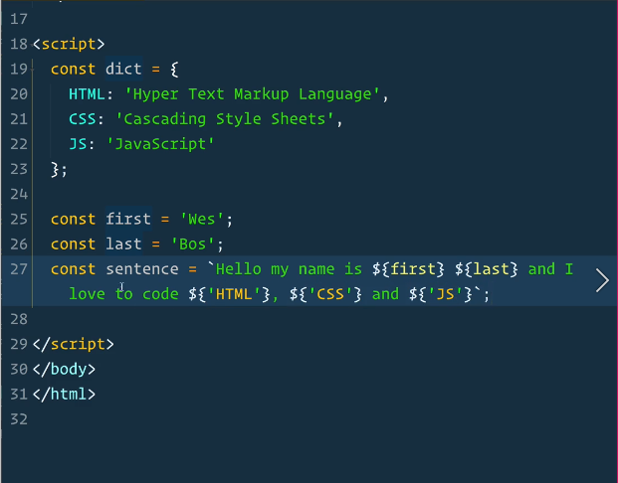

Above in our sentence you see an example of interpolation.

So what is interpolation? Well outside of code interpolation is: the insertion of something of a different nature into something else. But in our world of code it is more specific.

String Interpolation using Template Literals

The syntax for template literals will be a bit strange for anyone who is a JavaScript purist. First, you need to surround the string you want to interpolate with backticks, which you can find at the top left of your keyboard under the esc key (American keyboards).

"wrong"

'wrong'

`correct`

Second, you need to surround the JavaScript code that you want interpolated with these brackets: ${}. And yes, the $ is required.

`{wrong}`

`$wrong`

`${correct}`

Here’s what an example code snippet using ES6 template literals would look like:

const names = ['Curly', 'Moe', 'Larry'];

`The Three Stooges were ${names.slice(0, 2).join(', ')} and ${names[2]}.`

// "The Three Stooges were Curly, Moe and Larry."

Escaping Nested Quotes

One of the things I love about template strings is that they are declarative. You just need to write the string how you want it to look and the JavaScript interpreter will take care of the rest.

Take nested quotation marks for instance. Typically, if you wanted to create nested quotes, you would have to escape the quotation characters so the interpreter wouldn’t accidentally end the string early or switch between double and single quotes.

// ES5

"This is a \"nested string\"."

// or

'This is also a \'nested string\'.'

// or

"This is another 'nested string'."

Template literals remove that headache.

// ES6

`This is a "nested string".`

// "This is a \"nested string\"."

Multi-line Strings

Multi-line strings in ES5 are a pain. Not only do you need to include a new line character, \n, you need concatenate the strings across the lines as well.

// ES6

console.log(`string text line 1

string text line 2`);

// "string text line 1

// string text line 2"

Tagging

Tag functions are a great way to keep your code DRY. If you find yourself needing to interpolate strings over and over in the same way, you can create a tag function to do it for you.

The first argument passed into a tag function is the string you want to convert. The rest of the arguments correlate with any ${} expressions you have in your string. The function will parse those expressions out and use them.

// Tag Function

var person = 'Mike';

var age = 28;

function myTag(strings, personExp, ageExp) {

// The string is split using the expressions as delimiters.

// the 'strings' argument is returned as an array

// of the text snippets which you can access.

var str0 = strings[0]; // "that "

var str1 = strings[1]; // " is a "

var ageStr;

if (ageExp > 99){

ageStr = 'centenarian';

} else {

ageStr = 'youngster';

}

return str0 + personExp + str1 + ageStr;

}

var output = myTag`that ${ person } is a ${ age }`;

console.log(output);

// that Mike is a youngster

## Abreviations

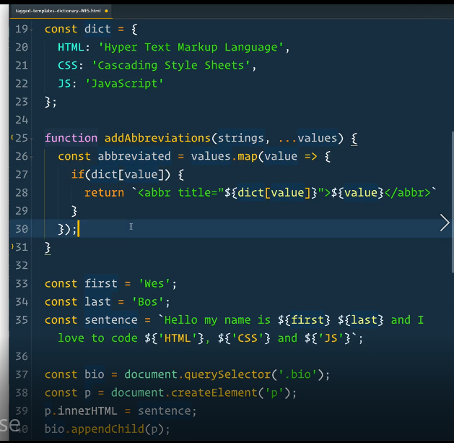

Don’t forget to return the value if it is not found in the array.

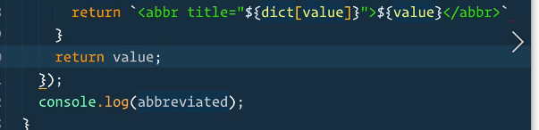

A couple of ways to get abbreviations or acronyms automatically from words

let abbrev = 'INTERNATIONAL Monetary Fund'.match(/\b([A-Z])/g).join('');

alert(abbrev);

let input = "Content Management System";

let abbr = input.match(/[A-Z]/g).join('');

let toMatch = "hyper text markup language";

let result = toMatch.replace(/(\w)\w*\W*/g, function (_, i) {

return i.toUpperCase();

}

)

alert(result);

## Sanitizing data

You have to stop users from running Java Script on your page with things they input or upload.

For our class we are using DOMPURIFY. <https://github.com/cure53/DOMPurify>

DOMPurify is a DOM-only, super-fast, uber-tolerant XSS sanitizer for HTML, MathML and SVG

DOMPurify sanitizes HTML and prevents XSS attacks. You can feed DOMPurify with string full of dirty HTML and it will return a string (unless configured otherwise) with clean HTML. DOMPurify will strip out everything that contains dangerous HTML and thereby prevent XSS attacks and other nastiness. It's also damn bloody fast. We use the technologies the browser provides and turn them into an XSS filter. The faster your browser, the faster DOMPurify will be.

It's easy. Just include DOMPurify on your website.

### Using the unminified development version

<script type="text/javascript" src="src/purify.js"></script>

### Using the minified and tested production version (source-map available)

<script type="text/javascript" src="dist/purify.min.js"></script>

Afterwards you can sanitize strings by executing the following code:

var clean = DOMPurify.sanitize(dirty);

The read me an GITHUB have examples of just about everything you may want to do with it.

## Class 04-30-2020

Recommended Book:

<https://eloquentjavascript.net/>

Home work :

Take the completed class work (in GITHUB REPO JAVA30 FlexPanel branch file name: FlexPanel-Finished.HTML

Your assignment:

1. Make side panel that does not react or change size.   Show small icon of photos and let users pick the photo for the panels from your list and either upload new or change the URL reference.
2. Allow the words to be photos that slide over the background photo
3. Allow the user to pick the number of panels which would mean number of photos.  Kind of like a collage maker that shows a larger portion of the individual photos when you click them

Extra credit

Let the user choose how the photo is centered so when it expands they are controlling which part of the larger photo you are seeing.